<https://leetcode.com/discuss/interview-question/398039/>

**Longest String Without 3 Consecutive Characters**

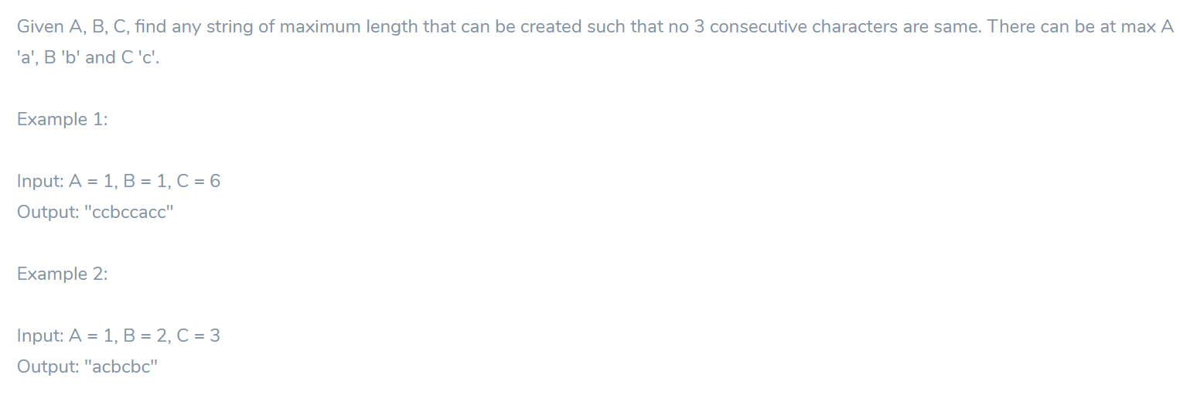

public static void main(String[] args) {

String s1 = "eedaaad";

String s2 = "xxxtxxx";

String s3 = "uuuuxaaaaxuuu";

System.out.println(getLongestSubstring(s1));

System.out.println(getLongestSubstring(s2));

System.out.println(getLongestSubstring(s3));

}

private static String getLongestSubstring(String s) {

StringBuilder sb = new StringBuilder();

sb.append(s.charAt(0));

int cnt = 1;

for(int r=1;r<s.length();r++) {

char c = s.charAt(r);

if(c == s.charAt(r-1))

cnt++;

else {

cnt = 1;

}

if(cnt < 3)

sb.append(c);

}

return sb.toString();

}